**Case Study**

**on**

**FULL STACK DEVELOPMENT**

**SUBMITTED BY: -**

**Neelesh Verma**

**CSJMA20001390159**

**Information Technology**

**GitHub Repository:** [**https://github.com/neelesh00 1122/Rojgar_khojo**](https://github.com/neelesh00%201122/Rojgar_khojo)

**GitHub Profile:** [**https://github.com/neelesh001122**](https://github.com/neelesh001122)

**CONTENTS:**

|  |  |
| --- | --- |
| **CHAPTER** | **PAGE NO.** |
| **CHAPTER-1** |  |
| **1. Introduction.** | **6-7** |
| **CHAPTER-2** |  |
| * **OBJECTIVE, SCOPE, LIMITATION & METHODOLOGY** | **11-14** |
| **CHAPTER-3** |  |
| * **Data Analysis.** | **15-23** |
| **CHAPTER-4** |  |
| * **Recommendation/Conclusion** | **24-26** |

**Introduction**

**Rojgar Khojo** is a cutting-edge job portal designed to connect job seekers with their dream careers and empower employers in finding the right talent. In the dynamic landscape of the job market, Rojgar Khojo stands out as a comprehensive platform that simplifies the job search and recruitment process for both candidates and employers.

Navigating through Rojgar Khojo is a seamless experience. Our user-centric interface ensures that job seekers and employers can effortlessly access the features they need with just a few clicks.

Discover a plethora of job opportunities spanning various industries and roles. Rojgar Khojo hosts a diverse range of job listings to cater to the career aspirations and skills of every job seeker.Finding the perfect job has never been easier. Our advanced search and filtering options allow job seekers to tailor their searches based on location, industry, experience level, and more, ensuring precision in job discovery.

For employers, Rojgar Khojo offers a dedicated dashboard for streamlined recruitment. Post job openings, manage applications, and track the hiring process efficiently, all within a user-friendly interface.Job seekers can keep track of their applications through our intuitive application tracking system, providing real-time updates on the status of their job applications.Build a standout professional profile to showcase your skills and experience. Rojgar Khojo allows job seekers to create personalized profiles that highlight their unique strengths and qualifications.

Access Rojgar Khojo anytime, anywhere. Our website is designed to be responsive across various devices, ensuring a seamless user experience whether you're on a computer, tablet, or smartphone.

### **Front-End Technologies:**

**HTML5 and CSS3:** Proficiency in creating structured and visually appealing web pages using the latest HTML and CSS standards.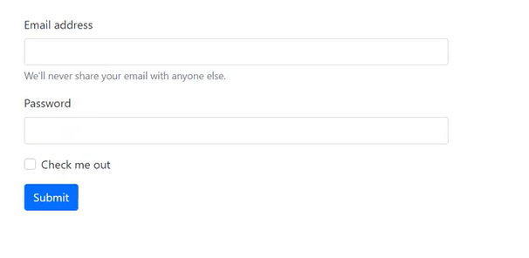



**JavaScript:** Implementing dynamic and interactive features on the website, enhancing the overall user experience.

**Responsive Design:** Ensuring the website is accessible and optimized across various devices and screen sizes.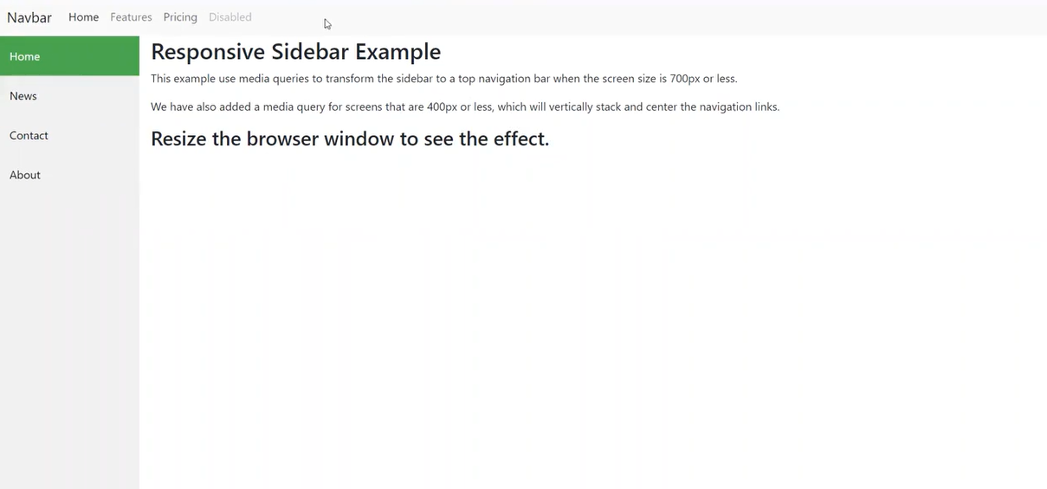

**Front-End Frameworks:**

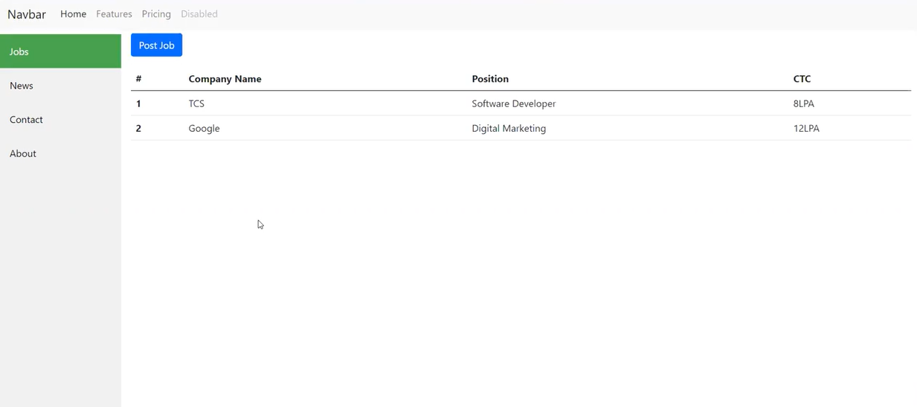

### **Back-End Development:**

**Server-Side Scripting:** Utilizing server-side scripting languages like [mention the specific language used, e.g., Node.js, Python, PHP] to handle server-side logic.

**Database Management:** Designing and implementing efficient database structures to store and manage user data, job listings, and application information.

**Server Deployment:** Configuring servers and deploying the web application to ensure optimal performance and reliability.

**Project methodology**

### Introduction to the Company and Project

### Front-End Development

### Back-End Development and Database Management

### Security and Authentication

### Project Management and Wrap-Up

### Continuous Learning Initiatives

### **Introduction to the Company and Project**

A detailed briefing on the Rojgar Sangam job portal project, including its objectives and key features.

Meet and interact with team members, understanding their roles and contributions to the project.

### **Front-End Development**

In-depth training on HTML5 and CSS3, focusing on creating structured and visually appealing web pages.

Introduction to JavaScript programming, covering basic syntax, variables, and control structures.

Understanding the principles of responsive design and implementing them in the Rojgar Sangam website.

### **Back-End Development and Database Management**

n-depth training on the server-side scripting language used.

Understanding database structures and implementing efficient data management for user profiles, job listings, and applications.

Hands-on experience with configuring servers and deploying the web application for optimal performance.

### **Security and Authentication**

Implementing secure user authentication processes to protect sensitive user information.

Learning and applying encryption techniques to ensure data security during transmission and storage.

Understanding and implementing best practices for web application security.

### **Project Management and Wrap-Up**

Understanding and applying Agile methodologies for effective project management.

Utilizing version control systems (e.g., Git) for collaborative development and code management.

Presenting the completed Rojgar Sangam website, receiving feedback, and discussing future improvements.

### **Continuous Learning Initiatives**

Participating in ongoing workshops and training sessions to stay updated on industry best practices.

Opportunities for continuous learning and professional growth within the field of web development.

This weekly breakdown provides an overview of the structured training program undertaken during the internship, highlighting the key areas of focus and the progression of learning throughout the duration.

**ABOUT PROJECT DETAIL**

A detailed briefing on the Rojgar Sangam job portal project, including its objectives and key features.

Meet and interact with team members, understanding their roles and contributions to the project.

In-depth training on HTML5 and CSS3, focusing on creating structured and visually appealing web pages.

Introduction to JavaScript programming, covering basic syntax, variables, and control structures.

Understanding the principles of responsive design and implementing them in the Rojgar Sangam website. n-depth training on the server-side scripting language used. Understanding database structures and implementing efficient data management for user profiles, job listings, and applications. Hands-on experience with configuring servers and deploying the web application for optimal performance.

Implementing secure user authentication processes to protect sensitive user information. Learning and applying encryption techniques to ensure data security during transmission and storage.

Understanding and implementing best practices for web application security. Understanding and applying Agile methodologies for effective project management. Utilizing version control systems (e.g., Git) for collaborative development and code management.

Presenting the completed Rojgar Sangam website, receiving feedback, and discussing future improvements.

Understanding and applying Agile methodologies for effective project management.

Utilizing version control systems (e.g., Git) for collaborative development and code management.

Presenting the completed Rojgar Sangam website, receiving feedback, and discussing future improvements.

## Mission and Vision:

**Rojgar Khojo** was founded with a clear mission: to empower individuals in their professional journeys and facilitate the seamless connection between talented job seekers and forward-thinking employers. Our vision is to be the go-to platform for job seekers and employers alike, fostering a dynamic and inclusive job market.

## Unique Selling Points:

### 1. **Industry-Centric Approach:**

Rojgar Khojo prides itself on its industry-centric approach. We collaborate closely with various industries to tailor our platform to the specific needs of professionals and organizations, ensuring a match that goes beyond skills and experience.

### 2. **Innovative Matching Algorithm:**

Our job matching algorithm goes beyond traditional keyword searches. Rojgar Khojo employs advanced data analytics to provide personalized job recommendations based on the unique preferences and qualifications of each user.

### 3. **Career Development Resources:**

Beyond job listings, Rojgar Khojo is committed to the holistic professional growth of its users. We offer a wealth of career development resources, including expert advice, skill-building webinars, and industry insights to keep our community informed and inspired.

## Community Engagement:

### 1. **Partnerships and Collaborations:**

Rojgar Khojo actively seeks partnerships with educational institutions, industry associations, and organizations committed to workforce development. These collaborations aim to enhance the skill sets of our users and broaden their professional networks.

### 2. **User Feedback and Iterative Development:**

We value user feedback as a cornerstone of our continuous improvement. Rojgar Khojo maintains an open channel for users to share their experiences, suggestions, and concerns, enabling us to implement iterative updates that align with user needs.

### 3. **Community Forums and Networking Events:**

Rojgar Khojo fosters a sense of community among its users. Community forums and networking events provide opportunities for professionals to connect, share insights, and build relationships that extend beyond the job search.

## Future Developments:

### 1. **Mobile Application Launch:**

Recognizing the importance of accessibility, Rojgar Khojo is actively developing a mobile application to provide users with on-the-go access to job opportunities, application tracking, and career development resources.

### 2. **Expanded Industry Partnerships:**

We are committed to expanding our industry partnerships to ensure that Rojgar Khojo remains at the forefront of industry trends and developments. This proactive engagement enables us to offer the most relevant opportunities to our users.

### 3. **AI-driven Features:**

Rojgar Khojo is investing in artificial intelligence to enhance user experience further. Future updates will include AI-driven features such as intelligent job matching, predictive analytics, and personalized career guidance.

As Rojgar Khojo continues to evolve, our dedication to facilitating meaningful professional connections, providing valuable resources, and adapting to the ever-changing job market remains unwavering.

Join Rojgar Khojo on the journey to redefine career success and foster a community where aspirations are realized

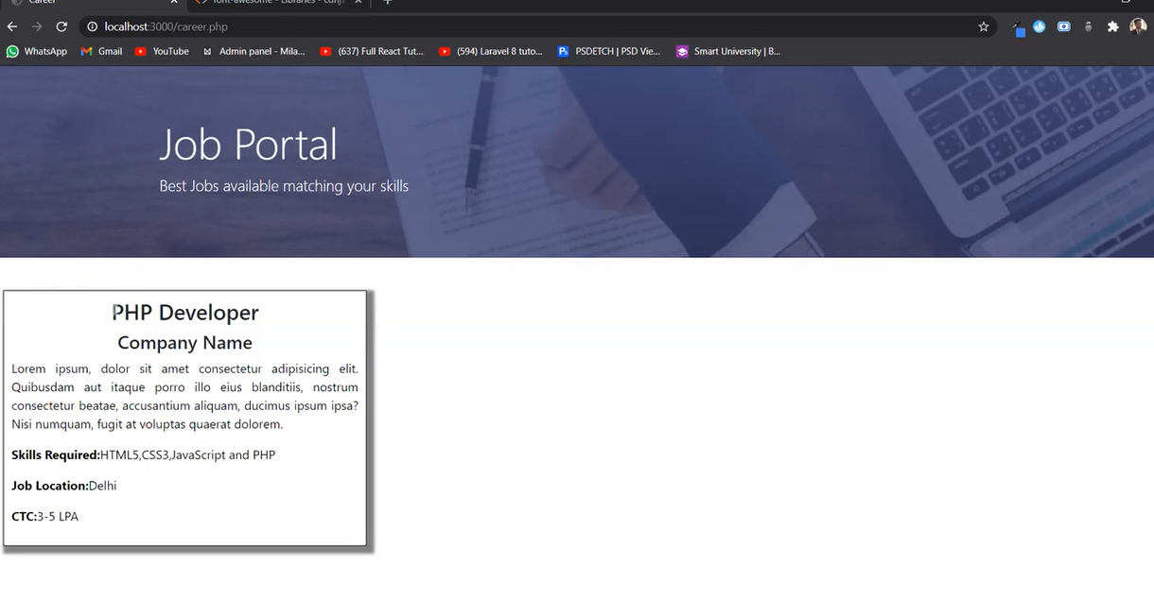

## **Recommendations:**

### 1. **User Engagement Enhancement:**

Based on user feedback and ongoing analysis, consider implementing additional features to enhance user engagement. This could include interactive forums, webinars, or gamified elements to keep users actively involved and informed about industry trends.

### 2. **Mobile Application Optimization:**

As mobile usage continues to rise, prioritize the optimization and launch of the mobile application. Ensure that the application is user-friendly, responsive, and provides a seamless experience for both job seekers and employers.

### 3. **AI Integration for Personalization:**

Explore the integration of artificial intelligence for personalized user experiences. This could involve implementing AI-driven job recommendations, personalized learning paths, and predictive analytics to better cater to individual user needs.

### 4. **Expanded Industry Collaborations:**

Continue to build and strengthen partnerships with industry associations, educational institutions, and key players in various sectors. These collaborations not only provide additional value to users but also contribute to the growth and relevance of Rojgar Khojo in the broader professional landscape.

### 5. **Continuous Feedback Mechanism:**

Establish a robust mechanism for collecting continuous user feedback. Regularly solicit input on user experiences, preferences, and any pain points they may encounter. This feedback loop is invaluable for making data-driven improvements and staying responsive to user needs.

## **Conclusion:**

In conclusion, the development and launch of Rojgar Khojo represent a significant milestone in redefining the job search and recruitment experience. The platform's commitment to innovation, user-centric design, and community engagement positions it as a leading player in the job portal landscape.

The success of Rojgar Khojo is not merely measured by the number of users but by the impact it has on individuals' professional lives. As the platform continues to evolve, it remains dedicated to facilitating meaningful connections, offering valuable resources, and adapting to the ever-changing dynamics of the job market.

As we look forward, Rojgar Khojo stands poised to be a beacon for professionals seeking opportunities and organizations in search of top-tier talent. By implementing the recommended strategies and staying true to its mission, Rojgar Khojo is well-positioned to contribute significantly to the success stories of countless individuals and businesses alike.